Sprint 2 Plan

Elevate

Completion Date: 11/4

Revision: 1, 10/23/17

# Goal:

We want to get the basic functionality of our app completed, including implementing the user’s ToDo list and the calendar view to display them.

# Task List:

* As a user I want to be able to create Daily tasks lists
  + Add reoccurring habits and non-reoccurring tasks to Firebase database (3 hours)
* As a user I want to visualize the completion of tasks/habits
  + Create Calendar View that can be populated with data about each day (2 hours)
  + Populate the Calendar View with Days colored based on number of tasks completed that day (5 hours)
  + Setup ToDo Fragment to write Task completion to Firebase’s database (2 hours)
  + Setup each calendar day to open the ToDo Fragment for the given day (2 hours)
  + Setup ToDo list Fragment to pull from Firebase database and Display that data (1 hours)
* As a user I want to be reminded to do habits
  + Use Firebase Cloud Messaging to create popup reminders to do habit/tasks (1.5 hours)
  + Setup popups to take us to the ToDo list (1 hours)
* As a group coming off a disorganized first sprint, we want to condense and standardize our code
  + Merge project into one and finalize project framework

# Team Roles:

Elisabeth (**Beth**) Oliver: Scrum Master, Firebase Database expert

**Joel** Sheng: Product Owner, App Standardizer

**Katie** Rosengrant: Firebase Cloud Messenger expert

**Jason** Wang: Calendar expert

**Sean** Corzine: Color Gradient expert

# Team Initial Task:

Elisabeth (**Beth**) Oliver: Setup ToDo Fragment to write Task completion to Firebase’s database

**Joel** Sheng: Merge project into one and finalize project framework

**Katie** Rosengrant: Use Firebase Cloud Messaging to create popup reminders to do habit/tasks

**Jason** Wang: Create Calendar View that can be populated with data about each day

**Sean** Corzine: Populate the Calendar View with Days colored based on number of tasks completed that day

# Initial Burn-Up Chart:

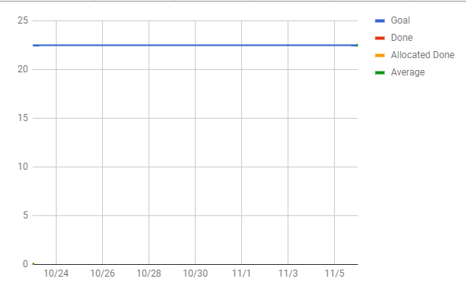

# Initial Scrum Board:The Scrum Board.

# Scrum Meeting Times:

Monday 11:40am

Tuesday 1:00 pm

Friday 11:20 am (With TA)